Business Unit
Mobile Failures Report
ASAP 7.0.2 – JAMU66

Week 35
August 27th to September 03rd, 2018

September 03rd, 2018

Contents

1 Percentages for all mobile activations, changes and deactivations Anguilla 4
2 Percentages for all mobile activations, changes and deactivations Antigua 5
3 Percentages for all mobile activations, changes and deactivations Barbados 6
4 Percentages for all mobile activations, changes and deactivations British Virgin Islands 7
5 Percentages for all mobile activations, changes and deactivations Cayman 8
6 Percentages for all mobile activations, changes and deactivations Dominica 9
7 Percentages for all mobile activations, changes and deactivations Grenada 10
8 Percentages for all mobile activations, changes and deactivations Jamaica 11
9 Percentages for all mobile activations, changes and deactivations Monserrat 12
10 Percentages for all mobile activations, changes and deactivations Saint Vincent 13
11 Percentages for all mobile activations, changes and deactivations Turks and Caicos 14
12 Percentages for all mobile activations, changes and deactivations Santa Lucia 15
13 Percentages for all mobile activations, changes and deactivations Saint Kitts and Nevis 16
14 Top 5 failure issues Anguilla 17
15 Top 5 failure issues Antigua 17
16 Top 5 failure issues Barbados 17
17 Top 5 failure issues British Virgin Islands 18
18 Top 5 failure issues Cayman 18
19 Top 5 failure issues Dominica 19
20 Top 5 failure issues Grenada 19
21 Top 5 failure issues Jamaica 19
22 Top 5 failure issues Monserrat 20
23 Top 5 failure issues Saint Vincent 20
24 Top 5 failure issues Turks and Caicos 20
25 Top 5 failure issues Santa Lucia 21
26 Top 5 failure issues Saint Kitts and Nevis 21
27 Failure numbers Anguilla 22
28 Failure numbers Antigua 22
29 Failure numbers Barbados 23
30 Failure numbers British Virgin Islands 24
31 Failure numbers Cayman 24
32 Failure numbers Dominica 27
33 Failure Numbers Grenada 27
34 Failure numbers Jamaica 28
35 Failure numbers Monserrat 29
36 Failure numbers Saint Vincent 29
37 Failure numbers Turks and Caicos 30
38 Failure numbers Santa Lucia 31
39 Failure numbers Saint Kitts and Nevis 32

Percentages for all mobile activations, changes and deactivations Anguilla

 | TOTAL | COMPLETE | FAILED | % Total | % COMPLETE | % FAILED
ACTIVATE | 53 | 53 | 0 | 8% | 100% | 0%
DEACTIVATE | 220 | 220 | 0 | 31% | 100% | 0%
MODIFY | 426 | 420 | 6 | 61% | 99% | 1%

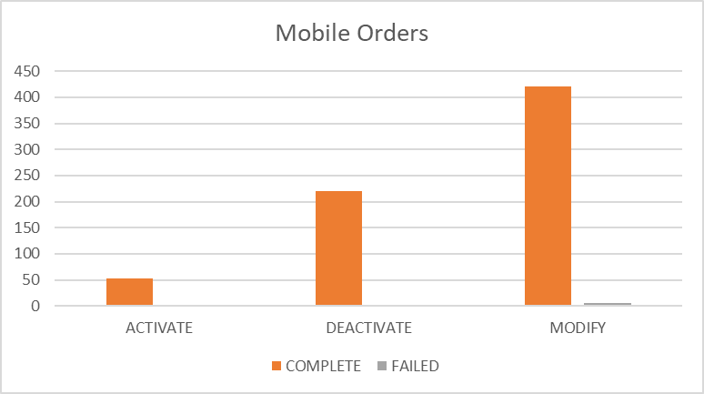

Percentages for all mobile activations, changes and deactivations Antigua

 | TOTAL | COMPLETE | FAILED | % Total | % COMPLETE | % FAILED
ACTIVATE | 87 | 74 | 13 | 6% | 85% | 15%
DEACTIVATE | 438 | 438 | 0 | 29% | 100% | 0%
MODIFY | 980 | 957 | 23 | 65% | 98% | 2%

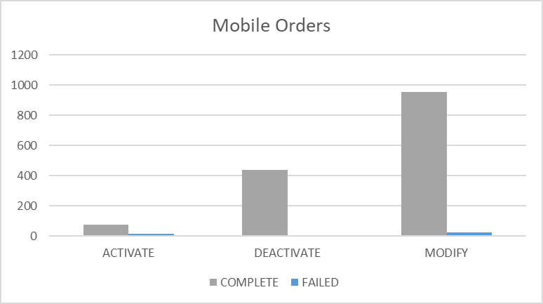

Percentages for all mobile activations, changes and deactivations Barbados

 | TOTAL | COMPLETE | FAILED | % Total | % COMPLETE | % FAILED
ACTIVATE | 30 | 12 | 18 | 1% | 40% | 60%
DEACTIVATE | 816 | 816 | 0 | 37% | 100% | 0%
MODIFY | 1353 | 1305 | 48 | 62% | 96% | 4%

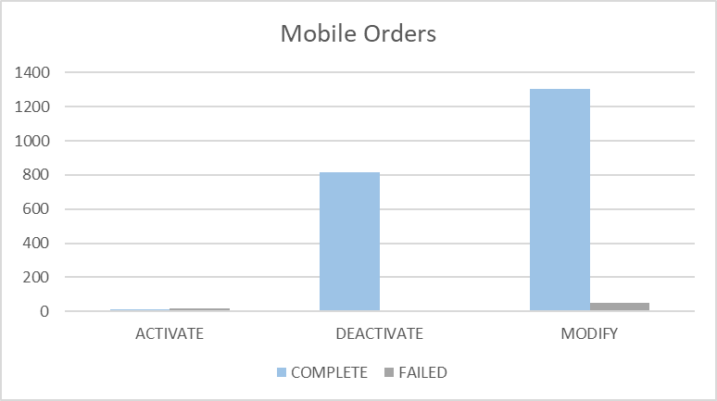

Percentages for all mobile activations, changes and deactivations British Virgin Islands

 | TOTAL | COMPLETE | FAILED | % Total | % COMPLETE | % FAILED
ACTIVATE | 209 | 209 | 0 | 8% | 100% | 0%
DEACTIVATE | 559 | 558 | 1 | 21% | 100% | 0%
MODIFY | 1861 | 1855 | 6 | 71% | 100% | 0%

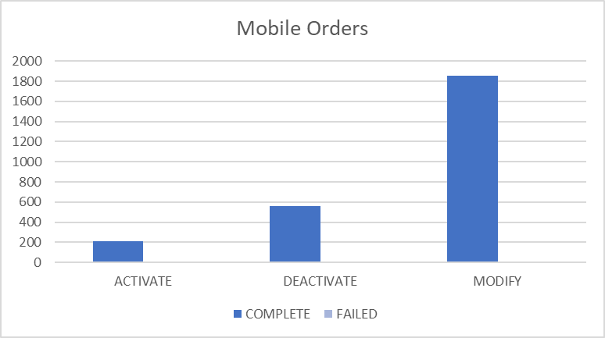

Percentages for all mobile activations, changes and deactivations Cayman

 | TOTAL | COMPLETE | FAILED | % Total | % COMPLETE | % FAILED
ACTIVATE | 92 | 90 | 2 | 2% | 98% | 2%
DEACTIVATE | 325 | 323 | 2 | 8% | 99% | 1%
MODIFY | 3507 | 3402 | 105 | 89% | 97% | 3%

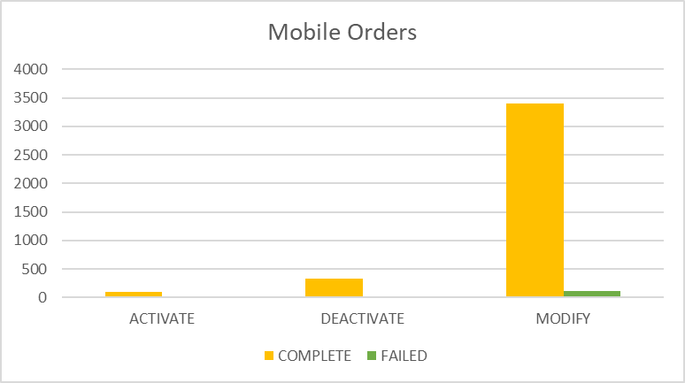

Percentages for all mobile activations, changes and deactivations Dominica

 | TOTAL | COMPLETE | FAILED | % Total | % COMPLETE | % FAILED
ACTIVATE | 590 | 588 | 2 | 24% | 100% | 0%
DEACTIVATE | 452 | 452 | 0 | 18% | 100% | 0%
MODIFY | 1465 | 1459 | 6 | 58% | 100% | 0%

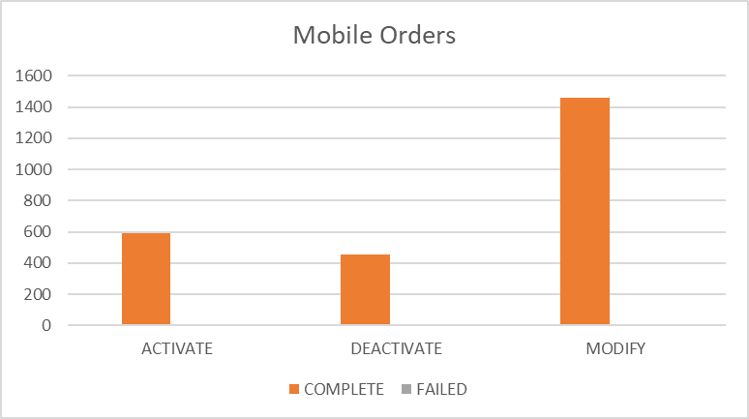

Percentages for all mobile activations, changes and deactivations Grenada

 | TOTAL | COMPLETE | FAILED | % Total | % COMPLETE | % FAILED
ACTIVATE | 155 | 154 | 1 | 7% | 99% | 1%
DEACTIVATE | 380 | 380 | 0 | 18% | 100% | 0%
MODIFY | 1621 | 1614 | 7 | 75% | 100% | 0%

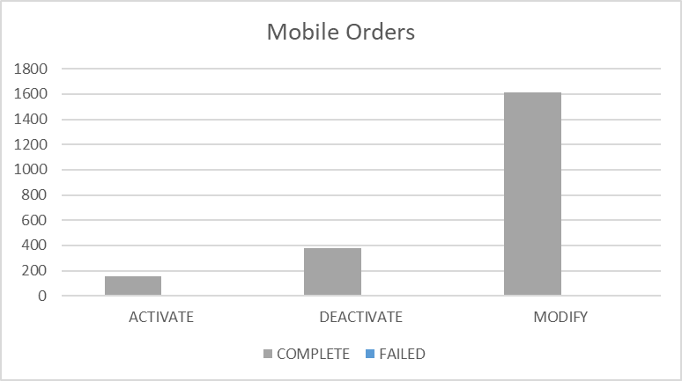

Percentages for all mobile activations, changes and deactivations Jamaica

 | TOTAL | COMPLETE | FAILED | % Total | % COMPLETE | % FAILED
ACTIVATE | 4051 | 4035 | 16 | 12% | 100% | 0%
DEACTIVATE | 6377 | 6369 | 8 | 19% | 100% | 0%
MODIFY | 22370 | 22316 | 54 | 68% | 100% | 0%

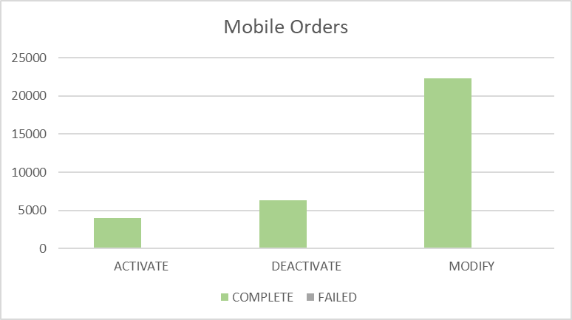

Percentages for all mobile activations, changes and deactivations Monserrat

 | TOTAL | COMPLETE | FAILED | % Total | % COMPLETE | % FAILED
ACTIVATE | 23 | 23 | 0 | 17% | 100% | 0%
DEACTIVATE | 29 | 29 | 0 | 21% | 100% | 0%
MODIFY | 86 | 86 | 0 | 62% | 100% | 0%

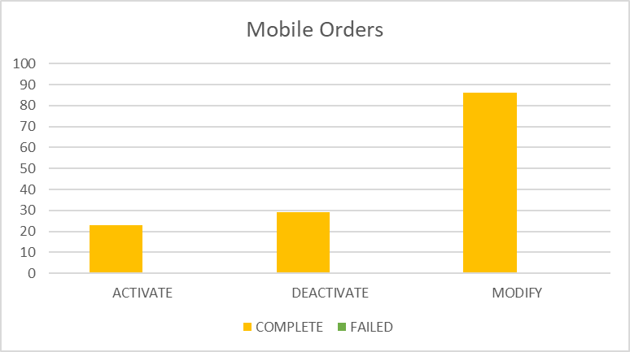

Percentages for all mobile activations, changes and deactivations Saint Vincent

 | TOTAL | COMPLETE | FAILED | % Total | % COMPLETE | % FAILED
ACTIVATE | 268 | 268 | 0 | 12% | 100% | 0%
DEACTIVATE | 681 | 681 | 0 | 31% | 100% | 0%
MODIFY | 1236 | 1233 | 3 | 57% | 100% | 0%

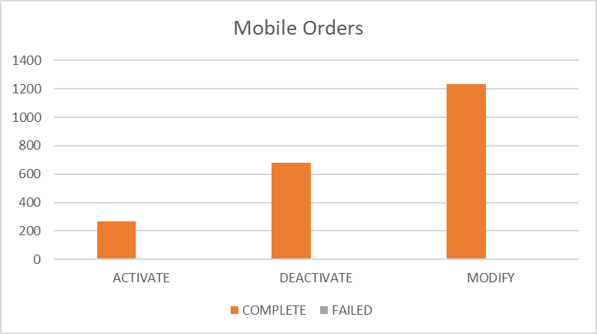

Percentages for all mobile activations, changes and deactivations Turks and Caicos

 | TOTAL | COMPLETE | FAILED | % Total | % COMPLETE | % FAILED
ACTIVATE | 171 | 154 | 17 | 13% | 90% | 10%
DEACTIVATE | 354 | 354 | 0 | 26% | 100% | 0%
MODIFY | 820 | 756 | 64 | 61% | 92% | 8%

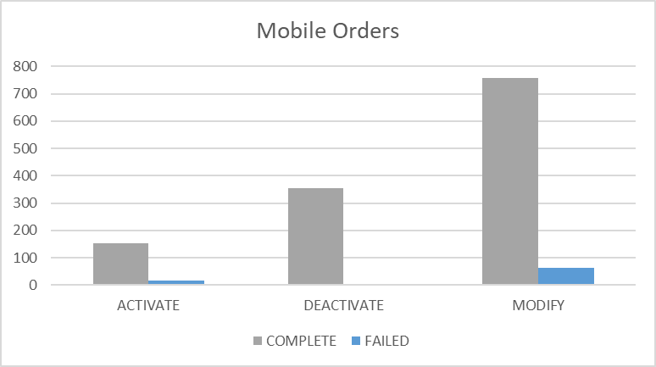

Percentages for all mobile activations, changes and deactivations Santa Lucia

 | TOTAL | COMPLETE | FAILED | % Total | % COMPLETE | % FAILED
ACTIVATE | 324 | 324 | 0 | 17% | 100% | 0%
DEACTIVATE | 402 | 402 | 0 | 21% | 100% | 0%
MODIFY | 1210 | 1203 | 7 | 63% | 99% | 1%

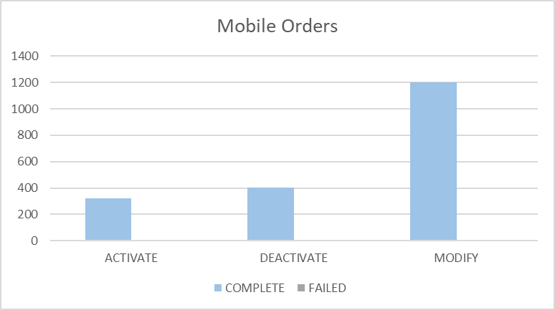

Percentages for all mobile activations, changes and deactivations Saint Kitts and Nevis

 | TOTAL | COMPLETE | FAILED | % Total | % COMPLETE | % FAILED
ACTIVATE | 302 | 274 | 28 | 22% | 91% | 9%
DEACTIVATE | 244 | 244 | 0 | 18% | 100% | 0%
MODIFY | 811 | 783 | 28 | 60% | 97% | 3%

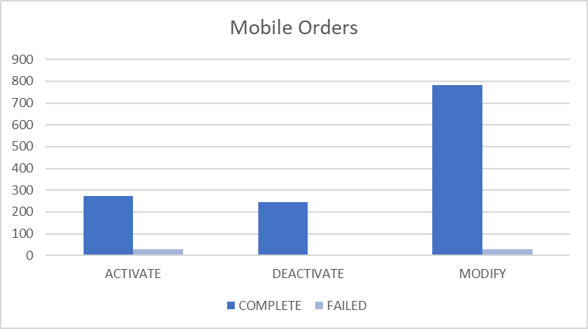

Top 5 failure issues Anguilla

AMOUNT | USER EXIT TYPES
3 | EMA_MISS_REQ_PARAM:Mandatory parameter is missing from work order
1 | EMA_RESP_1:The Specified IMSI is already defined
1 | FAIL:No such object
1 | EMA_RESP_35101:Missing or invalid parameter.

Top 5 failure issues Antigua

AMOUNT | USER EXIT TYPES
17 | EMA_RESP_35101:Missing or invalid parameter.
3 | EMA_MISS_REQ_PARAM:Mandatory parameter is missing from work order
3 | EMA_RESP_35105:The subscriber already exists.

Top 5 failure issues Barbados

AMOUNT | USER EXIT TYPES
17 | EMA_RESP_35101:Missing or invalid parameter.
9 | FAIL:No such object
7 | EMA_RESP_1:The Specified IMSI is already defined
6 | EMA_RESP_14:The Specified MSISDN is not defined
2 | EMA_MISS_REQ_PARAM:Mandatory parameter is missing from work order
2 | NGVM_ETTY_DSNT_EXST:The specified Mailbox ID does not exist on the Comverse Voicemail platform.
2 | EMA_RESP_13:The Specified IMSI is not defined
2 | EMA_RESP_2:The Specified MSISDN is already defined with a different IMSI
1 | SAPC_EXCEPTION:The NE was denid due to general exception

Top 5 failure issues British Virgin Islands

AMOUNT | USER EXIT TYPES
3 | EMA_RESP_13:The Specified IMSI is not defined
1 | EMA_MISS_REQ_PARAM:Mandatory parameter is missing from work order
1 | SAPC_PROVCARTEXP:The NE was denid due to provisioning cartridge exception
1 | LIME_BBRY_INVAL_DATA:Invalid Data

Top 5 failure issues Cayman

AMOUNT | USER EXIT TYPES
100 | EMA_RESP_35106:The subscriber does not exist.
2 | MMS10_NO_UDET_MATCH:No User Defined Exit Type Found
2 | EMA_RESP_35101:Missing or invalid parameter.
1 | FAIL:No such object

Top 5 failure issues Dominica

AMOUNT | USER EXIT TYPES
3 | EMA_RESP_14:The Specified MSISDN is not defined
2 | EMA_RESP_2:The Specified MSISDN is already defined with a different IMSI
1 | FAIL:No such object

Top 5 failure issues Grenada

AMOUNT | USER EXIT TYPES
4 | EMA_RESP_14:The Specified MSISDN is not defined
1 | FAIL:No such object
1 | EMA_RESP_2:The Specified MSISDN is already defined with a different IMSI
1 | SAPC_PROVCARTEXP:The NE was denid due to provisioning cartridge exception

Top 5 failure issues Jamaica

AMOUNT | USER EXIT TYPES
13 | EMA_RESP_35101:Missing or invalid parameter.
9 | SAPC_PROVCARTEXP:The NE was denid due to provisioning cartridge exception
8 | SAPC_EXCEPTION:The NE was denid due to general exception
5 | NGVM_ETTY_DSNT_EXST:The specified Mailbox ID does not exist on the Comverse Voicemail platform.
3 | NGVM_SUBS_USED:The subscriber key (TelephoneNumber, ExternalSubscriberId, etc.) is already in use by another subscriber.
3 | EMA_RESP_35106:The subscriber does not exist.
3 | EMA_RESP_1:The Specified IMSI is already defined
3 | EMA_RESP_1001:External system communication link failure.
2 | EMA_MISS_REQ_PARAM:Mandatory parameter is missing from work order
2 | EMA_RESP_13:The Specified IMSI is not defined
1 | EMA_RESP_35105:The subscriber already exists.
1 | FAIL:No User Defined Exit Type Found
1 | FAIL:No such object

Top 5 failure issues Monserrat

NO ROWS SELECTED

Top 5 failure issues Saint Vincent

AMOUNT | USER EXIT TYPES
1 | EMA_RESP_6:Subscriber authentication data not found
1 | NGVM_ETTY_DSNT_EXST:The specified Mailbox ID does not exist on the Comverse Voicemail platform.
1 | EMA_RESP_1:The Specified IMSI is already defined

Top 5 failure issues Turks and Caicos

AMOUNT | USER EXIT TYPES
41 | EMA_RESP_35101:Missing or invalid parameter.
19 | EMA_RESP_1:The Specified IMSI is already defined
3 | EMA_RESP_35105:The subscriber already exists.
1 | EMA_RESP_35106:The subscriber does not exist.

Top 5 failure issues Santa Lucia

AMOUNT | USER EXIT TYPES
2 | FAIL:No such object
1 | EMA_RESP_35105:The subscriber already exists.
1 | EMA_RESP_13:The Specified IMSI is not defined
1 | EMA_MISS_REQ_PARAM:Mandatory parameter is missing from work order
1 | SAPC_PROVCARTEXP:The NE was denid due to provisioning cartridge exception
1 | EMA_RESP_35101:Missing or invalid parameter.

Top 5 failure issues Saint Kitts and Nevis

AMOUNT | USER EXIT TYPES
28 | EMA_RESP_35105:The subscriber already exists.

Failure numbers Anguilla

SRQ_ID | WO_ID | WO_STATUS | MSISDN
1097817 | CIS:BAR:1141436:172.21.64.11:25010:1535378695479 | FAILED | 12647721767
1102189 | CIS:BAR:1141701:172.21.64.11:25010:1535400577260 | FAILED | 12647294832
1102242 | CIS:BAR:1141716:172.21.64.11:25010:1535401002426 | FAILED | 12647296021
1136163 | CIS:BAR:1142702:172.21.64.11:25010:1535642975069 | FAILED | 12644760054
1136188 | CIS:BAR:1142704:172.21.64.11:25010:1535643044319 | FAILED | 12644760054
1137027 | CIS:BAR:1142739:172.21.64.11:25010:1535646793555 | FAILED | 12642357252

Failure numbers Antigua

SRQ_ID | WO_ID | WO_STATUS | MSISDN
1100158 | CIS:BAR:3005028:172.21.64.6:25009:1535392047098 | FAILED | 12687700740
1101461 | CIS:BAR:3005080:172.21.64.6:25009:1535396888512 | FAILED | 12684649306
1113438 | CIS:BAR:3005881:172.21.64.6:25009:1535473502157 | FAILED | 12687641237
1115880 | CIS:BAR:3006029:172.21.64.6:25009:1535484442313 | FAILED | 12684646051
1116226 | CIS:BAR:3006051:172.21.64.6:25009:1535486319024 | FAILED | 12684647588
1122966 | CIS:BAR:3006261:172.21.64.6:25009:1535550248557 | FAILED | 12684642011
1123212 | CIS:BAR:3006313:172.21.64.6:25009:1535552663830 | FAILED | 12684642011
1136326 | CIS:BAR:3007051:172.21.64.6:25009:1535643370239 | FAILED | 12687647902
1138888 | CIS:BAR:3007486:172.21.64.6:25009:1535656688420 | FAILED | 12687780419
1147351 | CIS:BAR:3007950:172.21.64.6:25009:1535720494237 | FAILED | 12687720461
1147839 | CIS:BAR:3008024:172.21.64.6:25009:1535724177949 | FAILED | 12687716050
1148276 | CIS:BAR:3008073:172.21.64.6:25009:1535726514127 | FAILED | 12687647186
1148365 | CIS:BAR:3008081:172.21.64.6:25009:1535727111382 | FAILED | 12684648872
1148395 | CIS:BAR:3008091:172.21.64.6:25009:1535727297858 | FAILED | 12684648873
1148430 | CIS:BAR:3008110:172.21.64.6:25009:1535727464859 | FAILED | 12684648835
1148489 | CIS:BAR:3008117:172.21.64.6:25009:1535727643875 | FAILED | 12684648836
1148528 | CIS:BAR:3008122:172.21.64.6:25009:1535727821371 | FAILED | 12684648847
1150514 | CIS:BAR:3008355:172.21.64.6:25009:1535736787288 | FAILED | 12687725897
1151267 | CIS:BAR:3008376:172.21.64.6:25009:1535739696759 | FAILED | 12687795778
1151989 | CIS:BAR:3008414:172.21.64.6:25009:1535742913387 | FAILED | 12687642610
1156264 | CIS:BAR:3008616:172.21.64.6:25009:1535808935903 | FAILED | 12687281307
1156348 | CIS:BAR:3008639:172.21.64.6:25009:1535810703391 | FAILED | 12684644470
1157930 | CIS:BAR:3008780:172.21.64.6:25009:1535825382273 | FAILED | 12684647674

Failure numbers Barbados

SRQ_ID | WO_ID | WO_STATUS | MSISDN
1101183 | CIS:BAR:23816076:172.21.64.13:25001:1535395088494 | FAILED | 12462337310
1102140 | OCA-6740 | FAILED | 12462300182
1106217 | OCA-6748 | FAILED | 12462431460
1110721 | CIS:BAR:23817140:172.21.64.13:25001:1535469205768 | FAILED | 12462536627
1110773 | CIS:BAR:23817143:172.21.64.13:25001:1535469266399 | FAILED | 12462536627
1113836 | CIS:BAR:23817198:172.21.64.13:25001:1535474854803 | FAILED | 12462457315
1113892 | CIS:BAR:23817213:172.21.64.13:25001:1535475314444 | FAILED | 12462457315
1113896 | CIS:BAR:23817219:172.21.64.13:25001:1535475349684 | FAILED | 12462457315
1113918 | CIS:BAR:23817221:172.21.64.13:25001:1535475466850 | FAILED | 12462457315
1113933 | CIS:BAR:23817226:172.21.64.13:25001:1535475563661 | FAILED | 12462457315
1114847 | OCA-6776 | FAILED | 12462334633
1114991 | OCA-6778 | FAILED | 12462334633
1115230 | OCA-6781 | FAILED | 12462838596
1115241 | OCA-6782 | FAILED | 12462838596
1116805 | OCA-6797 | FAILED | 12462314395
1123457 | OCA-6809 | FAILED | 12462433764
1123575 | CIS:BAR:23817749:172.21.64.13:25001:1535555524530 | FAILED | 12462392634
1123597 | CIS:BAR:23817753:172.21.64.13:25001:1535555679463 | FAILED | 12462392634
1123608 | CIS:BAR:23817754:172.21.64.13:25001:1535555786067 | FAILED | 12462392634
1123611 | CIS:BAR:23817755:172.21.64.13:25001:1535555803352 | FAILED | 12462392634
1123757 | CIS:BAR:23817763:172.21.64.13:25001:1535556320497 | FAILED | 12462392634
1123851 | CIS:BAR:23817768:172.21.64.13:25001:1535556415959 | FAILED | 12462392634
1124262 | CIS:BAR:23817776:172.21.64.13:25001:1535556803633 | FAILED | 12462392634
1124329 | CIS:BAR:23817781:172.21.64.13:25001:1535556867212 | FAILED | 12462392634
1124802 | OCA-6822 | FAILED | 12462300921
1125887 | OCA-6826 | FAILED | 12462317763
1125897 | OCA-6839 | FAILED | 12462317763
1134566 | OCA-6866 | FAILED | 12462316502
1134583 | OCA-6881 | FAILED | 12462323911
1134584 | OCA-6882 | FAILED | 12462323911
1134681 | OCA-6893 | FAILED | 12462307128
1135205 | CIS:BAR:23818640:172.21.64.13:25001:1535634364476 | FAILED | 12462502390
1135210 | CIS:BAR:23818644:172.21.64.13:25001:1535634462986 | FAILED | 12462502390
1135300 | OCA-6898 | FAILED | 12462306762
1137588 | CIS:BAR:23818693:172.21.64.13:25001:1535649500054 | FAILED | 12462489084
1137603 | CIS:BAR:23818699:172.21.64.13:25001:1535649594265 | FAILED | 12462489084
1137618 | CIS:BAR:23818701:172.21.64.13:25001:1535649706745 | FAILED | 12462489084
1137637 | CIS:BAR:23818703:172.21.64.13:25001:1535649832179 | FAILED | 12462489084
1137645 | CIS:BAR:23818705:172.21.64.13:25001:1535649897950 | FAILED | 12462489084
1137679 | CIS:BAR:23818707:172.21.64.13:25001:1535650201997 | FAILED | 12462489084
1138366 | CIS:BAR:23818725:172.21.64.13:25001:1535653620016 | FAILED | 12462489084
1138375 | CIS:BAR:23818727:172.21.64.13:25001:1535653692764 | FAILED | 12462489084
1138386 | CIS:BAR:23818728:172.21.64.13:25001:1535653801772 | FAILED | 12462489084
1138417 | CIS:BAR:23818729:172.21.64.13:25001:1535653853359 | FAILED | 12462489084
1138558 | CIS:BAR:23818736:172.21.64.13:25001:1535654368827 | FAILED | 12462489084
1138570 | CIS:BAR:23818741:172.21.64.13:25001:1535654441295 | FAILED | 12462489084
1150601 | CIS:BAR:23819597:172.21.64.13:25001:1535737305359 | FAILED | 12462898329
1150614 | CIS:BAR:23819599:172.21.64.13:25001:1535737352500 | FAILED | 12462898329

Failure numbers British Virgin Islands

SRQ_ID | WO_ID | WO_STATUS | MSISDN
1113010 | CIS:BAR:2896866:172.21.64.3:25002:1535472311765 | FAILED | 12845424932
1113064 | CIS:BAR:2897073:172.21.64.3:25002:1535472361347 | FAILED | 12845425704
1128998 | CIS:BAR:2900119:172.21.64.3:25002:1535582064923 | FAILED | 12845429038
1148243 | CIS:BAR:2902278:172.21.64.3:25002:1535726235394 | FAILED | 12845425704
1152489 | CIS:BAR:2902737:172.21.64.3:25002:1535745392393 | FAILED | 12845426876
1156401 | CIS:BAR:2902902:172.21.64.3:25002:1535811725145 | FAILED | 12845435210

Failure numbers Cayman

SRQ_ID | WO_ID | WO_STATUS | MSISDN
1096027 | CIS:CAY:6094103:172.21.64.16:25003:1535361763561 | FAILED | 13459172275
1102986 | CIS:CAY:6094767:172.21.64.16:25003:1535406879911 | FAILED | 13459160551
1109253 | CIS:CAY:6095134:172.21.64.16:25003:1535465721221 | FAILED | 13459382274
1109856 | CIS:CAY:6095199:172.21.64.16:25003:1535468369582 | FAILED | 13459252320
1109891 | CIS:CAY:6095288:172.21.64.16:25003:1535468394801 | FAILED | 13459163079
1109936 | CIS:CAY:6095401:172.21.64.16:25003:1535468427383 | FAILED | 13459161696
1110033 | CIS:CAY:6095721:172.21.64.16:25003:1535468520884 | FAILED | 13459385540
1110077 | CIS:CAY:6095854:172.21.64.16:25003:1535468560249 | FAILED | 13459264228
1110124 | CIS:CAY:6096059:172.21.64.16:25003:1535468616652 | FAILED | 13459260692
1110982 | CIS:CAY:6099308:172.21.64.16:25003:1535469488964 | FAILED | 13459255553
1111052 | CIS:CAY:6099552:172.21.64.16:25003:1535469554396 | FAILED | 13459255950
1111146 | CIS:CAY:6099963:172.21.64.16:25003:1535469659702 | FAILED | 13459389124
1111433 | CIS:CAY:6100677:172.21.64.16:25003:1535469897612 | FAILED | 13459297477
1111462 | CIS:CAY:6100766:172.21.64.16:25003:1535469929474 | FAILED | 13459170808
1111499 | CIS:CAY:6100912:172.21.64.16:25003:1535469970764 | FAILED | 13459255547
1111536 | CIS:CAY:6101068:172.21.64.16:25003:1535470014535 | FAILED | 13459166249
1111544 | CIS:CAY:6101091:172.21.64.16:25003:1535470021768 | FAILED | 13459168183
1111548 | CIS:CAY:6101102:172.21.64.16:25003:1535470024603 | FAILED | 13459266845
1111559 | CIS:CAY:6101145:172.21.64.16:25003:1535470036396 | FAILED | 13459257919
1111581 | CIS:CAY:6101204:172.21.64.16:25003:1535470056766 | FAILED | 13459167499
1111612 | CIS:CAY:6101310:172.21.64.16:25003:1535470089116 | FAILED | 13459164877
1111679 | CIS:CAY:6101575:172.21.64.16:25003:1535470159647 | FAILED | 13459387220
1111721 | CIS:CAY:6101709:172.21.64.16:25003:1535470200518 | FAILED | 13453213259
1111748 | CIS:CAY:6101811:172.21.64.16:25003:1535470227315 | FAILED | 13459279726
1111970 | CIS:CAY:6102784:172.21.64.16:25003:1535470486142 | FAILED | 13459267363
1111991 | CIS:CAY:6102850:172.21.64.16:25003:1535470503692 | FAILED | 13459161248
1112162 | CIS:CAY:6103446:172.21.64.16:25003:1535470678847 | FAILED | 13459271236
1112394 | CIS:CAY:6104356:172.21.64.16:25003:1535470931785 | FAILED | 13459252759
1113370 | CIS:CAY:6104954:172.21.64.16:25003:1535473263001 | FAILED | 13459164877
1113921 | CIS:CAY:6105236:172.21.64.16:25003:1535475481566 | FAILED | 13459166249
1114085 | CIS:CAY:6105314:172.21.64.16:25003:1535476169873 | FAILED | 13459255950
1114902 | CIS:CAY:6105718:172.21.64.16:25003:1535480728194 | FAILED | 13459252759
1115374 | CIS:CAY:6105924:172.21.64.16:25003:1535482536440 | FAILED | 13459170808
1115701 | CIS:CAY:6106001:172.21.64.16:25003:1535483368882 | FAILED | 13459161248
1115861 | CIS:CAY:6106106:172.21.64.16:25003:1535484326993 | FAILED | 13459161696
1116332 | CIS:CAY:6106304:172.21.64.16:25003:1535486990097 | FAILED | 13459161696
1116342 | CIS:CAY:6106308:172.21.64.16:25003:1535487083543 | FAILED | 13459161696
1116461 | CIS:CAY:6106375:172.21.64.16:25003:1535487697689 | FAILED | 13459386614
1116628 | CIS:CAY:6106435:172.21.64.16:25003:1535488625678 | FAILED | 13459386614
1116892 | CIS:CAY:6106569:172.21.64.16:25003:1535490087725 | FAILED | 13459260692
1116893 | CIS:CAY:6106571:172.21.64.16:25003:1535490095105 | FAILED | 13459252320
1117060 | CIS:CAY:6106650:172.21.64.16:25003:1535491577896 | FAILED | 13459386614
1118897 | CIS:CAY:6106898:172.21.64.16:25003:1535497195473 | FAILED | 13459279726
1123035 | CIS:CAY:6107281:172.21.64.16:25003:1535550962175 | FAILED | 13459264228
1123697 | CIS:CAY:6107657:172.21.64.16:25003:1535556275646 | FAILED | 13459262710
1123715 | CIS:CAY:6107699:172.21.64.16:25003:1535556287149 | FAILED | 13459162291
1123724 | CIS:CAY:6107723:172.21.64.16:25003:1535556294256 | FAILED | 13459260230
1123756 | CIS:CAY:6107835:172.21.64.16:25003:1535556323941 | FAILED | 13459164813
1123776 | CIS:CAY:6107896:172.21.64.16:25003:1535556341190 | FAILED | 13459269506
1123785 | CIS:CAY:6107938:172.21.64.16:25003:1535556350408 | FAILED | 13459265900
1123810 | CIS:CAY:6108031:172.21.64.16:25003:1535556375296 | FAILED | 13459160848
1123844 | CIS:CAY:6108172:172.21.64.16:25003:1535556412556 | FAILED | 13459258445
1123848 | CIS:CAY:6108193:172.21.64.16:25003:1535556418440 | FAILED | 13459162093
1123886 | CIS:CAY:6108346:172.21.64.16:25003:1535556460998 | FAILED | 13459261418
1123963 | CIS:CAY:6108636:172.21.64.16:25003:1535556536950 | FAILED | 13459163363
1123987 | CIS:CAY:6108729:172.21.64.16:25003:1535556563910 | FAILED | 13459165010
1124116 | CIS:CAY:6109039:172.21.64.16:25003:1535556662869 | FAILED | 13459276518
1124117 | CIS:CAY:6109045:172.21.64.16:25003:1535556663771 | FAILED | 13459168304
1124183 | CIS:CAY:6109279:172.21.64.16:25003:1535556721427 | FAILED | 13453235988
1124247 | CIS:CAY:6109582:172.21.64.16:25003:1535556794722 | FAILED | 13459254147
1124301 | CIS:CAY:6109756:172.21.64.16:25003:1535556845242 | FAILED | 13459254187
1124342 | CIS:CAY:6109903:172.21.64.16:25003:1535556881535 | FAILED | 13459220242
1124348 | CIS:CAY:6109919:172.21.64.16:25003:1535556886655 | FAILED | 13459261991
1124425 | CIS:CAY:6110160:172.21.64.16:25003:1535556970577 | FAILED | 13459281448
1124689 | CIS:CAY:6110567:172.21.64.16:25003:1535558962299 | FAILED | 13459164813
1124822 | CIS:CAY:6110672:172.21.64.16:25003:1535559989956 | FAILED | 13459261991
1125128 | CIS:CAY:6110775:172.21.64.16:25003:1535561042583 | FAILED | 13459271236
1125182 | CIS:CAY:6110837:172.21.64.16:25003:1535561393727 | FAILED | 13459267363
1125288 | CIS:CAY:6110895:172.21.64.16:25003:1535561965214 | FAILED | 13459162291
1125530 | CIS:CAY:6111124:172.21.64.16:25003:1535563522446 | FAILED | 13459260230
1125746 | CIS:CAY:6111247:172.21.64.16:25003:1535564604705 | FAILED | 13459269506
1125805 | CIS:CAY:6111281:172.21.64.16:25003:1535564959861 | FAILED | 13459265900
1126699 | CIS:CAY:6111641:172.21.64.16:25003:1535570601025 | FAILED | 13459162093
1127169 | CIS:CAY:6111790:172.21.64.16:25003:1535573721975 | FAILED | 13459247238
1127261 | CIS:CAY:6111842:172.21.64.16:25003:1535574440980 | FAILED | 13459258445
1127387 | CIS:CAY:6111901:172.21.64.16:25003:1535575400681 | FAILED | 13459163079
1127390 | CIS:CAY:6111905:172.21.64.16:25003:1535575402201 | FAILED | 13459165010
1127546 | CIS:CAY:6112102:172.21.64.16:25003:1535576603462 | FAILED | 13459261418
1127884 | CIS:CAY:6112282:172.21.64.16:25003:1535578518561 | FAILED | 13459168304
1128804 | CIS:CAY:6112531:172.21.64.16:25003:1535581399029 | FAILED | 13459262710
1129390 | CIS:CAY:6112800:172.21.64.16:25003:1535586789150 | FAILED | 13459382274
1130110 | CIS:CAY:6112842:172.21.64.16:25003:1535589830975 | FAILED | 13459276518
1130186 | CIS:CAY:6112856:172.21.64.16:25003:1535590678495 | FAILED | 13459281448
1130240 | CIS:CAY:6112889:172.21.64.16:25003:1535593452456 | FAILED | 13459167499
1137702 | CIS:CAY:6113998:172.21.64.16:25003:1535650244785 | FAILED | 13459168669
1137760 | CIS:CAY:6114014:172.21.64.16:25003:1535650315920 | FAILED | 13459268404
1137763 | CIS:CAY:6114018:172.21.64.16:25003:1535650317589 | FAILED | 13459273538
1137935 | CIS:CAY:6114157:172.21.64.16:25003:1535651315001 | FAILED | 13459292799
1137978 | CIS:CAY:6114187:172.21.64.16:25003:1535651498710 | FAILED | 13459391649
1138217 | CIS:CAY:6114296:172.21.64.16:25003:1535652556465 | FAILED | 13453235988
1138929 | CIS:CAY:6114541:172.21.64.16:25003:1535657118088 | FAILED | 13459254147
1139419 | CIS:CAY:6114686:172.21.64.16:25003:1535659875832 | FAILED | 13459268404
1139421 | CIS:CAY:6114690:172.21.64.16:25003:1535659877452 | FAILED | 13459273538
1140440 | CIS:CAY:6115009:172.21.64.16:25003:1535666031266 | FAILED | 13459254187
1141184 | CIS:CAY:6115116:172.21.64.16:25003:1535669046239 | FAILED | 13459391649
1141498 | CIS:CAY:6115170:172.21.64.16:25003:1535670917333 | FAILED | 13459266845
1141543 | CIS:CAY:6115204:172.21.64.16:25003:1535671516312 | FAILED | 13459220242
1145937 | CIS:CAY:6115504:172.21.64.16:25003:1535707426193 | FAILED | 13459299995
1148773 | CIS:CAY:6115808:172.21.64.16:25003:1535729114002 | FAILED | 13453213259
1148942 | CIS:JAM:6115863:172.21.64.16:25003:1535729690195 | FAILED | 13459383588
1150240 | CIS:CAY:6116190:172.21.64.16:25003:1535735622753 | FAILED | 13459168669
1150572 | CIS:CAY:6116293:172.21.64.16:25003:1535737072960 | FAILED | 13459160521
1152764 | CIS:CAY:6116665:172.21.64.16:25003:1535746391613 | FAILED | 13459387220
1158494 | CIS:CAY:6118223:172.21.64.16:25003:1535830867587 | FAILED | 13459292799
1162463 | CIS:CAY:6118744:172.21.64.16:25003:1535934421406 | FAILED | 13459275875

Failure numbers Dominica

SRQ_ID | WO_ID | WO_STATUS | MSISDN
1113807 | CIS:BAR:4288996:172.21.64.4:25008:1535474664920 | FAILED | 17672351332
1120919 | CIS:BAR:4290146:172.21.64.4:25008:1535514126674 | FAILED | 17672451426
1121078 | CIS:BAR:4290946:172.21.64.4:25008:1535514797745 | FAILED | 17672650780
1127312 | CIS:BAR:4292473:172.21.64.4:25008:1535574737510 | FAILED | 17672769166
1127316 | CIS:BAR:4292475:172.21.64.4:25008:1535574799101 | FAILED | 17672769166
1127323 | CIS:BAR:4292476:172.21.64.4:25008:1535574902073 | FAILED | 17672769166

Failure Numbers Grenada

SRQ_ID | WO_ID | WO_STATUS | MSISDN
1097816 | CIS:BAR:5498229:172.21.64.14:25004:1535378693429 | FAILED | 14734590029
1097859 | CIS:BAR:5498279:172.21.64.14:25004:1535379102469 | FAILED | 14734590029
1097866 | CIS:BAR:5498284:172.21.64.14:25004:1535379157786 | FAILED | 14734590029
1097954 | CIS:BAR:5498334:172.21.64.14:25004:1535379889711 | FAILED | 14734590029
1109609 | CIS:BAR:5505198:172.21.64.14:25004:1535467062624 | FAILED | 14734581880
1125164 | OCA-6828 | FAILED | 14734050287
1125174 | OCA-6830 | FAILED | 14734076367

Failure numbers Jamaica

SRQ_ID | WO_ID | WO_STATUS | MSISDN
1098593 | CIS:JAM:186225244:172.21.64.17:25007:1535384037373 | FAILED | 18768152082
1098863 | CIS:JAM:186225928:172.21.64.17:25007:1535385672285 | FAILED | 18763132097
1099023 | CIS:JAM:186226393:172.21.64.17:25007:1535386875639 | FAILED | 18767891498
1099028 | CIS:JAM:186226405:172.21.64.17:25007:1535386894181 | FAILED | 18769990031
1102828 | CIS:JAM:186235111:172.21.64.17:25007:1535405533864 | FAILED | 18763228313
1102829 | CIS:JAM:186235113:172.21.64.17:25007:1535405534520 | FAILED | 18768337463
1103489 | CIS:JAM:186238005:172.21.64.17:25007:1535408866369 | FAILED | 18769979003
1108933 | CIS:JAM:186266432:172.21.64.17:25007:1535462989600 | FAILED | 18763222888
1108933 | CIS:JAM:186266432:172.21.64.17:25007:1535462989600 | FAILED | 18768188885
1109435 | CIS:JAM:186267079:172.21.64.17:25007:1535466440114 | FAILED | 18763219418
1114399 | CIS:JAM:177172069:172.21.64.99:25007:1535477588049 | FAILED | 18766000122
1114435 | CIS:JAM:186272403:172.21.64.17:25007:1535477754632 | FAILED | 18769954014
1114887 | CIS:JAM:186273342:172.21.64.17:25007:1535480642913 | FAILED | 18765122324
1117460 | CIS:JAM:186280241:172.21.64.17:25007:1535493806917 | FAILED | 18763194990
1118765 | CIS:JAM:186286290:172.21.64.17:25007:1535496840268 | FAILED | 18768264426
1123662 | CIS:JAM:177172089:172.21.64.99:25007:1535556133155 | FAILED | 18769951460
1123667 | CIS:JAM:177172092:172.21.64.99:25007:1535556154408 | FAILED | 18769951460
1126913 | CIS:JAM:186312956:172.21.64.17:25007:1535572096816 | FAILED | 18769973410
1127218 | CIS:JAM:186313990:172.21.64.17:25007:1535574034222 | FAILED | 18768331838
1128751 | CIS:JAM:186319238:172.21.64.17:25007:1535581218342 | FAILED | 18768058906
1135795 | CIS:JAM:186487635:172.21.64.17:25007:1535640382893 | FAILED | 18768058906
1135862 | CIS:JAM:186487756:172.21.64.17:25007:1535640823033 | FAILED | 18768058906
1135887 | CIS:JAM:186487803:172.21.64.17:25007:1535641079076 | FAILED | 18768058906
1135926 | CIS:JAM:186487849:172.21.64.17:25007:1535641438587 | FAILED | 18768058906
1135934 | CIS:JAM:186487865:172.21.64.17:25007:1535641559545 | FAILED | 18768058906
1136897 | CIS:JAM:186490233:172.21.64.17:25007:1535646037140 | FAILED | 18768224474
1137911 | CIS:JAM:186492964:172.21.64.17:25007:1535651112385 | FAILED | 18763220587
1137912 | CIS:JAM:186492966:172.21.64.17:25007:1535651112908 | FAILED | 18767766535
1138289 | CIS:JAM:186493859:172.21.64.17:25007:1535653066692 | FAILED | 18769904121
1139342 | CIS:JAM:186496639:172.21.64.17:25007:1535659368054 | FAILED | 18765445128
1139776 | CIS:JAM:186498072:172.21.64.17:25007:1535661653444 | FAILED | 18768327778
1139954 | CIS:JAM:186498661:172.21.64.17:25007:1535662835672 | FAILED | 18769992457
1140922 | CIS:JAM:186503177:172.21.64.17:25007:1535668132221 | FAILED | 18765981130
1140922 | CIS:JAM:186503177:172.21.64.17:25007:1535668132221 | FAILED | 18767906962
1143895 | CIS:JAM:186516453:172.21.64.17:25007:1535687582611 | FAILED | 18769951238
1147352 | CIS:JAM:186528290:172.21.64.17:25007:1535720531386 | FAILED | 18768250805
1147416 | CIS:JAM:186528429:172.21.64.17:25007:1535721234027 | FAILED | 18768235600
1149461 | CIS:JAM:186533700:172.21.64.17:25007:1535732528333 | FAILED | 18763228313
1151984 | CIS:JAM:186540417:172.21.64.17:25007:1535742888045 | FAILED | 18768129982
1151984 | CIS:JAM:186540417:172.21.64.17:25007:1535742888045 | FAILED | 18769974760
1152008 | CIS:JAM:186540486:172.21.64.17:25007:1535743024414 | FAILED | 18769903402
1152021 | CIS:JAM:186540523:172.21.64.17:25007:1535743095894 | FAILED | 18768129982
1152021 | CIS:JAM:186540523:172.21.64.17:25007:1535743095894 | FAILED | 18769974760
1152035 | CIS:JAM:186540570:172.21.64.17:25007:1535743187026 | FAILED | 18768129982
1152035 | CIS:JAM:186540570:172.21.64.17:25007:1535743187026 | FAILED | 18769974760
1152053 | CIS:JAM:186540615:172.21.64.17:25007:1535743288064 | FAILED | 18769955429
1152060 | CIS:JAM:186540629:172.21.64.17:25007:1535743350746 | FAILED | 18768322822
1152060 | CIS:JAM:186540629:172.21.64.17:25007:1535743350746 | FAILED | 18769974760
1152089 | CIS:JAM:186540699:172.21.64.17:25007:1535743568873 | FAILED | 18768322822
1152089 | CIS:JAM:186540699:172.21.64.17:25007:1535743568873 | FAILED | 18769974760
1156707 | CIS:JAM:186557949:172.21.64.17:25007:1535815529100 | FAILED | 18763405987
1156707 | CIS:JAM:186557949:172.21.64.17:25007:1535815529100 | FAILED | 18768333370
1158558 | CIS:JAM:186562805:172.21.64.17:25007:1535831664268 | FAILED | 18763371238
1158559 | CIS:JAM:186562806:172.21.64.17:25007:1535831665151 | FAILED | 18765416016
1158560 | CIS:JAM:186562807:172.21.64.17:25007:1535831666027 | FAILED | 18765433064
1158562 | CIS:JAM:186562809:172.21.64.17:25007:1535831667713 | FAILED | 18767847299
1158563 | CIS:JAM:186562810:172.21.64.17:25007:1535831668550 | FAILED | 18768062141
1158569 | CIS:JAM:186562829:172.21.64.17:25007:1535831731374 | FAILED | 18768062141
1159202 | CIS:JAM:186564750:172.21.64.17:25007:1535838839526 | FAILED | 18768336863
1159297 | CIS:JAM:186565059:172.21.64.17:25007:1535839441544 | FAILED | 18768336863
1159356 | CIS:JAM:186565251:172.21.64.17:25007:1535840446417 | FAILED | 18768330646
1159906 | CIS:JAM:186567553:172.21.64.17:25007:1535862680393 | FAILED | 18768327425

Failure numbers Monserrat

NO ROWS SELECTED

Failure numbers Saint Vincent

SRQ_ID | WO_ID | WO_STATUS | MSISDN
1115481 | CIS:SOU:3460561:172.21.64.8:25012:1535482640847 | FAILED | 17845938024
1135470 | CIS:BAR:3463171:172.21.64.8:25012:1535638272559 | FAILED | 17844541839
1147277 | CIS:BAR:3464644:172.21.64.8:25012:1535719298401 | FAILED | 17844929777

Failure numbers Turks and Caicos

SRQ_ID | WO_ID | WO_STATUS | MSISDN
1097498 | CIS:BAR:2489876:172.21.64.5:25007:1535374054231 | FAILED | 16494411039
1097500 | CIS:BAR:2489878:172.21.64.5:25007:1535374117955 | FAILED | 16494411039
1097653 | CIS:BAR:2489926:172.21.64.5:25007:1535376694880 | FAILED | 16492327969
1097797 | CIS:BAR:2489953:172.21.64.5:25007:1535378525724 | FAILED | 16492422646
1097806 | CIS:BAR:2489955:172.21.64.5:25007:1535378609087 | FAILED | 16492422646
1097833 | CIS:BAR:2489965:172.21.64.5:25007:1535378847872 | FAILED | 16492422646
1097953 | CIS:BAR:2489978:172.21.64.5:25007:1535379887950 | FAILED | 16492418560
1097975 | CIS:BAR:2489980:172.21.64.5:25007:1535380083710 | FAILED | 16492418560
1099395 | CIS:BAR:2490135:172.21.64.5:25007:1535389280118 | FAILED | 16492434242
1101196 | CIS:BAR:2490271:172.21.64.5:25007:1535395251157 | FAILED | 16492328249
1101466 | CIS:BAR:2490301:172.21.64.5:25007:1535396949992 | FAILED | 16494422549
1101902 | CIS:BAR:2490329:172.21.64.5:25007:1535399209302 | FAILED | 16492410524
1101933 | CIS:BAR:2490331:172.21.64.5:25007:1535399435346 | FAILED | 16492410524
1109122 | CIS:BAR:2490707:172.21.64.5:25007:1535464689547 | FAILED | 16494418687
1109127 | CIS:BAR:2490709:172.21.64.5:25007:1535464733136 | FAILED | 16494418687
1109227 | CIS:BAR:2490723:172.21.64.5:25007:1535465609158 | FAILED | 16494414357
1109329 | CIS:BAR:2490731:172.21.64.5:25007:1535465939495 | FAILED | 16492457194
1111119 | CIS:BAR:2490804:172.21.64.5:25007:1535469631138 | FAILED | 16492311805
1114440 | CIS:BAR:2490925:172.21.64.5:25007:1535477839070 | FAILED | 16492469764
1114805 | CIS:BAR:2490980:172.21.64.5:25007:1535480113995 | FAILED | 16492418705
1117026 | CIS:BAR:2491101:172.21.64.5:25007:1535491178219 | FAILED | 16492423786
1122756 | CIS:BAR:2491223:172.21.64.5:25007:1535547225389 | FAILED | 16494418687
1122759 | CIS:BAR:2491227:172.21.64.5:25007:1535547316971 | FAILED | 16494418687
1122776 | CIS:BAR:2491231:172.21.64.5:25007:1535547417785 | FAILED | 16494418687
1122953 | CIS:BAR:2491242:172.21.64.5:25007:1535550124799 | FAILED | 16492321243
1135376 | CIS:BAR:2492115:172.21.64.5:25007:1535637167300 | FAILED | 16492421203
1135428 | CIS:BAR:2492125:172.21.64.5:25007:1535637941204 | FAILED | 16492443824
1135439 | CIS:BAR:2492127:172.21.64.5:25007:1535638042826 | FAILED | 16492443824
1135468 | CIS:BAR:2492143:172.21.64.5:25007:1535638253776 | FAILED | 16492443824
1135539 | CIS:BAR:2492156:172.21.64.5:25007:1535638725167 | FAILED | 16492410871
1135572 | CIS:BAR:2492158:172.21.64.5:25007:1535638912723 | FAILED | 16492425427
1135578 | CIS:BAR:2492159:172.21.64.5:25007:1535638969759 | FAILED | 16492414873
1135582 | CIS:BAR:2492160:172.21.64.5:25007:1535638981066 | FAILED | 16492410871
1135583 | CIS:BAR:2492161:172.21.64.5:25007:1535638984556 | FAILED | 16492425427
1135597 | CIS:BAR:2492163:172.21.64.5:25007:1535639027123 | FAILED | 16492414873
1135756 | CIS:BAR:2492174:172.21.64.5:25007:1535640059321 | FAILED | 16492424842
1135763 | CIS:BAR:2492176:172.21.64.5:25007:1535640132543 | FAILED | 16492424842
1135771 | CIS:BAR:2492177:172.21.64.5:25007:1535640201798 | FAILED | 16492471041
1135791 | CIS:BAR:2492179:172.21.64.5:25007:1535640357942 | FAILED | 16492467245
1135796 | CIS:BAR:2492180:172.21.64.5:25007:1535640390753 | FAILED | 16492467245
1135808 | CIS:BAR:2492185:172.21.64.5:25007:1535640462899 | FAILED | 16492413914
1135810 | CIS:BAR:2492186:172.21.64.5:25007:1535640476948 | FAILED | 16492471041
1135831 | CIS:BAR:2492191:172.21.64.5:25007:1535640591347 | FAILED | 16492424842
1135837 | CIS:BAR:2492196:172.21.64.5:25007:1535640661424 | FAILED | 16492424842
1135847 | CIS:BAR:2492200:172.21.64.5:25007:1535640701603 | FAILED | 16492424842
1135868 | CIS:BAR:2492206:172.21.64.5:25007:1535640859833 | FAILED | 16492413914
1136229 | CIS:BAR:2492252:172.21.64.5:25007:1535643151263 | FAILED | 16494325454
1136814 | CIS:BAR:2492300:172.21.64.5:25007:1535645579354 | FAILED | 16492443824
1136821 | CIS:BAR:2492301:172.21.64.5:25007:1535645646033 | FAILED | 16492443824
1136890 | CIS:BAR:2492315:172.21.64.5:25007:1535645962914 | FAILED | 16492443824
1136916 | CIS:BAR:2492322:172.21.64.5:25007:1535646134162 | FAILED | 16492443824
1138585 | CIS:BAR:2492455:172.21.64.5:25007:1535654609611 | FAILED | 16492430093
1138596 | CIS:BAR:2492457:172.21.64.5:25007:1535654718624 | FAILED | 16492430093
1138979 | CIS:BAR:2492508:172.21.64.5:25007:1535657376653 | FAILED | 16494421956
1138987 | CIS:BAR:2492510:172.21.64.5:25007:1535657421862 | FAILED | 16494421956
1147426 | CIS:BAR:2492854:172.21.64.5:25007:1535721487631 | FAILED | 16492423561
1150142 | CIS:BAR:2493099:172.21.64.5:25007:1535735080108 | FAILED | 16492439688
1150246 | CIS:BAR:2493114:172.21.64.5:25007:1535735637183 | FAILED | 16492472445
1150391 | CIS:BAR:2493132:172.21.64.5:25007:1535736361072 | FAILED | 16492435382
1150412 | CIS:BAR:2493135:172.21.64.5:25007:1535736490895 | FAILED | 16492435382
1152517 | CIS:BAR:2493331:172.21.64.5:25007:1535745548328 | FAILED | 16492474220
1156389 | CIS:BAR:2493457:172.21.64.5:25007:1535811489191 | FAILED | 16492465023
1158570 | CIS:BAR:2493530:172.21.64.5:25007:1535831750755 | FAILED | 16492428864
1159302 | CIS:BAR:2493543:172.21.64.5:25007:1535839500838 | FAILED | 16492328101

Failure numbers Santa Lucia

SRQ_ID | WO_ID | WO_STATUS | MSISDN
1097448 | CIS:BAR:8603972:172.21.64.7:25011:1535371984923 | FAILED | 17584892216
1097521 | CIS:BAR:8604007:172.21.64.7:25011:1535374748585 | FAILED | 17582844389
1101529 | CIS:BAR:8604645:172.21.64.7:25011:1535397323604 | FAILED | 17582852273
1103564 | CIS:BAR:8604859:172.21.64.7:25011:1535409126783 | FAILED | 17584841857
1135821 | CIS:BAR:8608439:172.21.64.7:25011:1535640546372 | FAILED | 17582852348
1136041 | CIS:BAR:8608473:172.21.64.7:25011:1535642261681 | FAILED | 17582858537
1151895 | CIS:BAR:8609983:172.21.64.7:25011:1535742247094 | FAILED | 17583847555

Failure numbers Saint Kitts and Nevis

SRQ_ID | WO_ID | WO_STATUS | MSISDN
1125634 | CIS:BAR:3673101:172.21.64.12:25006:1535563995478 | FAILED | 18696644071
1125654 | CIS:BAR:3673115:172.21.64.12:25006:1535564127613 | FAILED | 18696644071
1125655 | CIS:BAR:3673118:172.21.64.12:25006:1535564132833 | FAILED | 18696647348
1125670 | CIS:BAR:3673126:172.21.64.12:25006:1535564217189 | FAILED | 18696644071
1125672 | CIS:BAR:3673129:172.21.64.12:25006:1535564222277 | FAILED | 18696647348
1125673 | CIS:BAR:3673132:172.21.64.12:25006:1535564227363 | FAILED | 18696646270
1125695 | CIS:BAR:3673150:172.21.64.12:25006:1535564311745 | FAILED | 18696644071
1125697 | CIS:BAR:3673153:172.21.64.12:25006:1535564316869 | FAILED | 18696647348
1125698 | CIS:BAR:3673156:172.21.64.12:25006:1535564322016 | FAILED | 18696646270
1125699 | CIS:BAR:3673159:172.21.64.12:25006:1535564327204 | FAILED | 18696632194
1125710 | CIS:BAR:3673166:172.21.64.12:25006:1535564422668 | FAILED | 18696644071
1125711 | CIS:BAR:3673169:172.21.64.12:25006:1535564427745 | FAILED | 18696647348
1125712 | CIS:BAR:3673172:172.21.64.12:25006:1535564432918 | FAILED | 18696646270
1125713 | CIS:BAR:3673175:172.21.64.12:25006:1535564437963 | FAILED | 18696632194
1125715 | CIS:BAR:3673178:172.21.64.12:25006:1535564443217 | FAILED | 18696637265
1125806 | CIS:BAR:3673217:172.21.64.12:25006:1535564965113 | FAILED | 18696644071
1125808 | CIS:BAR:3673220:172.21.64.12:25006:1535564970242 | FAILED | 18696647348
1125809 | CIS:BAR:3673223:172.21.64.12:25006:1535564975421 | FAILED | 18696646270
1125811 | CIS:BAR:3673226:172.21.64.12:25006:1535564980510 | FAILED | 18696632194
1125812 | CIS:BAR:3673229:172.21.64.12:25006:1535564985722 | FAILED | 18696637265
1125814 | CIS:BAR:3673232:172.21.64.12:25006:1535564990886 | FAILED | 18696640400
1125869 | CIS:BAR:3673247:172.21.64.12:25006:1535565203140 | FAILED | 18696644071
1125871 | CIS:BAR:3673250:172.21.64.12:25006:1535565208385 | FAILED | 18696647348
1125872 | CIS:BAR:3673253:172.21.64.12:25006:1535565213586 | FAILED | 18696646270
1125873 | CIS:BAR:3673256:172.21.64.12:25006:1535565218876 | FAILED | 18696632194
1125874 | CIS:BAR:3673259:172.21.64.12:25006:1535565223974 | FAILED | 18696637265
1125875 | CIS:BAR:3673262:172.21.64.12:25006:1535565229096 | FAILED | 18696640400
1125877 | CIS:BAR:3673265:172.21.64.12:25006:1535565234336 | FAILED | 18696689559

